CHAPTER 1: Introduction

1. INTRODUCTION

Agriculture management system

1. PROJECT BACKGROUND AND MOTIVATION

Currently, there are some systems which deals with agriculture

1. PROBLEM STATEMENT

* Limited focus on crop cultivation in Zanzibar: The existing system primarily caters to Tanzania and does not provide specific information on crop cultivation in Zanzibar.
* Lack of a comprehensive budgeting tool: The system does not offer a detailed budget template, hindering farmers from effectively managing their expenses.
* Absence of supply for fertilizers and pesticides in Zanzibar: While Barefoot supplies in Tanzania, there's a gap in providing these resources specifically for Zanzibar.
* Language barrier: The existing system is in English, which may not be accessible to all farmers, especially those more comfortable with Swahili.
* Limited emphasis on crop-related information: Agriweb focuses more on animals, leaving a gap in crop-related information and resources.
* Absence of direct input for farmers post-harvest: The system lacks a feature for farmers to input information after harvest, such as yields and profits.

1. PROBLEMS SOLUTION AND SCOPE

**Problem solution**

* Expansion to include information on crop cultivation in Zanzibar.
* Development of a detailed budget template for crop cultivation to assist farmers in managing their expenses effectively.
* Establishment of a supply chain for fertilizers and pesticides in Zanzibar.
* Translation of the existing system into Swahili for broader accessibility.
* Inclusion of crop-specific information and resources.
* Integration of a feature for farmers to input post-harvest data, such as yields and profits.

**SCOPE**

1. **Geographical Scope:**
   * The system will cover both Tanzania and Zanzibar, providing information and support tailored to the specific agricultural practices and needs of farmers in these regions.
2. **Crop Cultivation:**
   * The system will extensively focus on crop cultivation, offering guidance on various crops, cultivation techniques, and best practices.
3. **Budgeting and Financial Management:**
   * A comprehensive budgeting tool will be included to assist farmers in planning, tracking, and managing their expenses related to crop cultivation.
4. **Post-Harvest Data Input:**
   * A feature will be integrated to allow farmers to input information post-harvest, such as yields and profits, enabling them to analyze the success of their cultivation efforts and make informed decisions for future seasons.
5. **User-Friendly Interface:**
   * The system will have an intuitive and user-friendly interface, making it accessible to farmers with varying levels of technological expertise.
6. **Education and Resources:**
   * In addition to cultivation and budgeting tools, the system will provide educational resources, and guidelines to empower farmers with knowledge and skills for sustainable and successful crop cultivation.
7. **Collaboration with Local Stores:**
   * Information on reputable local stores for obtaining fertilizers and pesticides will be included, fostering collaboration between the system and trusted suppliers.
8. OBJECTIVES

CHAPTER 2: Literature review

CHAPTER 3: Project Methodology

1. Introduction

2. Software development approach (object oriented or structured)

Object-Oriented Approach

3. Software development life cycle model (SDLC)

Agile

4. Software development tools

1. For designing: draw.io
2. System development platform:
3. DBMS: PostgreSQL
4. Front-end tools:

5. Information Gathering and Analysis

6. System Analysis

**USE CASE DIAGRAM**

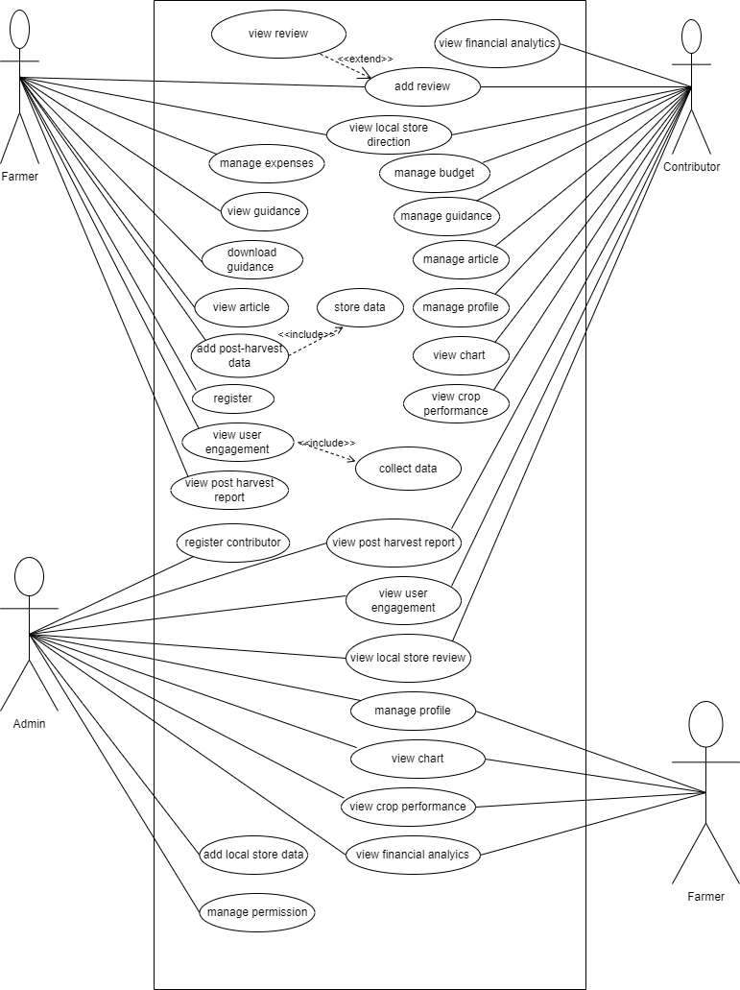

**SEQUENCE DIAGRAM**

Farmer self registration UML Sequence diagram

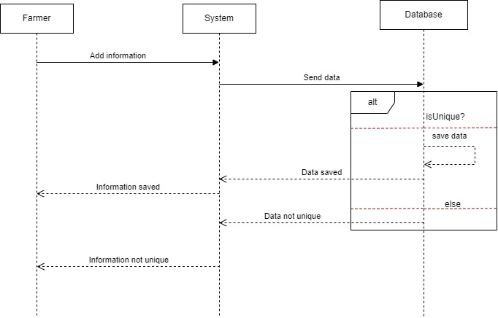

Narration

Login UML Sequence diagram

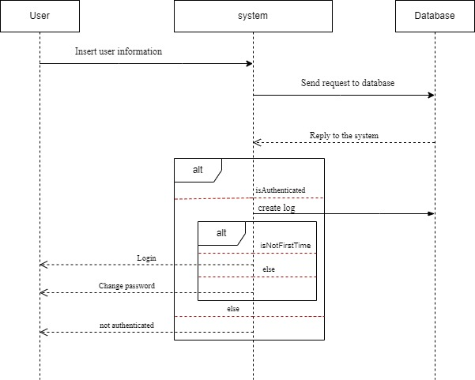

Narration

Logout UML Sequence diagram

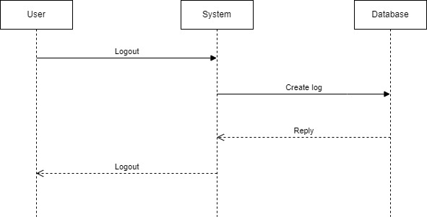

Narration

Manage Data UML Sequence diagram

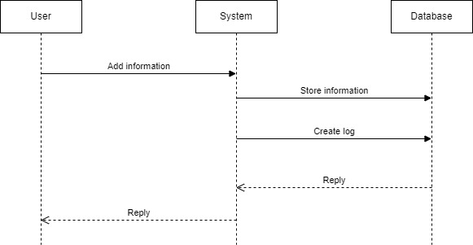

Narration

Download UML Sequence diagram

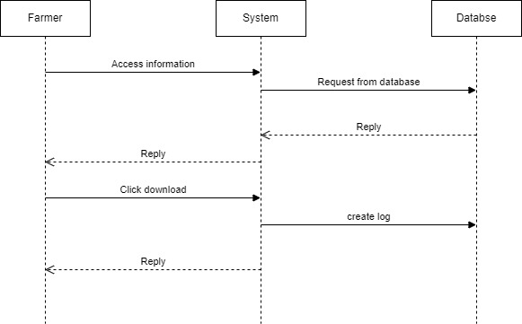

Narration

**CLASS DIAGRAM**